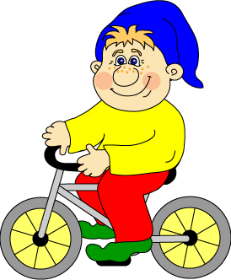
My name is Jeanette and I cannot wait to finally meet YOU!
I’m sure we could do so many exciting things together and would have a lot of fun.
If the weather is fine and the sun is shining we can go to the playground, meet your friends, go bicycling, swimming, hiking or maybe even go snorkeling.
When it’s snowy outside we can build a snowman, go ice skating or skiing.
On rainy days there are a lot of things to do at home: play the guitar and sing together, tinker, bake cookies or your favourite meal,…
I have so many ideas for great activities that we can do together and I’m sure you’ll never get bored.
I’m really looking forward to join your family!
Yours
Jeanette

